**SQL – Assignment : 1**

* SQL Query to create the database.

create Database Northwind_database

output:

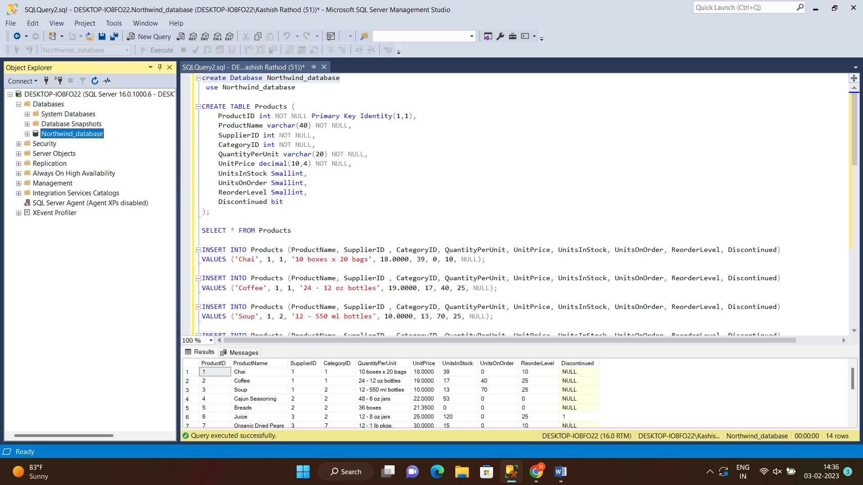

* SQL Query to create the table with column name with filled data.

CREATE TABLE Products (

ProductID int NOT NULL Primary Key Identity(1,1),

ProductName varchar(40) NOT NULL,

SupplierID int NOT NULL,

CategoryID int NOT NULL,

QuantityPerUnit varchar(20) NOT NULL,

UnitPrice decimal(10,4) NOT NULL,

UnitsInStock Smallint,

UnitsOnOrder Smallint,

ReorderLevel Smallint,

Discontinued bit

);

INSERT INTO Products (ProductName, SupplierID , CategoryID, QuantityPerUnit, UnitPrice, UnitsInStock, UnitsOnOrder, ReorderLevel, Discontinued)

VALUES ('Chai', 1, 1, 10, 18.0000, 39, 0, 10, 0);

INSERT INTO Products (ProductName, SupplierID , CategoryID, QuantityPerUnit, UnitPrice, UnitsInStock, UnitsOnOrder, ReorderLevel, Discontinued)

VALUES ('Coffee', 1, 1, 24, 19.0000, 17, 40, 25, 0);

INSERT INTO Products (ProductName, SupplierID , CategoryID, QuantityPerUnit, UnitPrice, UnitsInStock, UnitsOnOrder, ReorderLevel, Discontinued)

VALUES ('Soup', 1, 2, 12, 10.0000, 13, 70, 25, 0);

INSERT INTO Products (ProductName, SupplierID , CategoryID, QuantityPerUnit, UnitPrice, UnitsInStock, UnitsOnOrder, ReorderLevel, Discontinued)

VALUES ('Cajun Seasoning ', 2, 2, 48, 22.0000, 53, 0, 0, 0);

INSERT INTO Products (ProductName, SupplierID , CategoryID, QuantityPerUnit, UnitPrice, UnitsInStock, UnitsOnOrder, ReorderLevel, Discontinued)

VALUES ('Breads', 2, 2, 36, 21.3500, 0, 0, 0, 0);

INSERT INTO Products (ProductName, SupplierID , CategoryID, QuantityPerUnit, UnitPrice, UnitsInStock, UnitsOnOrder, ReorderLevel, Discontinued)

VALUES ('Juice', 3, 2, 12, 25.0000, 120, 0, 25, 1);

INSERT INTO Products (ProductName, SupplierID , CategoryID, QuantityPerUnit, UnitPrice, UnitsInStock, UnitsOnOrder, ReorderLevel, Discontinued)

VALUES ('Organic Dried Pears', 3, 7, 12, 30.0000, 15, 0, 10, 0);

INSERT INTO Products (ProductName, SupplierID , CategoryID, QuantityPerUnit, UnitPrice, UnitsInStock, UnitsOnOrder, ReorderLevel, Discontinued)

VALUES ('Cranberry Sauce', 3, 2, 12, 40.0000, 6, 0, 0, 0);

INSERT INTO Products (ProductName, SupplierID , CategoryID, QuantityPerUnit, UnitPrice, UnitsInStock, UnitsOnOrder, ReorderLevel, Discontinued)

VALUES ('Almonds', 4, 6, 18, 97.0000, 29, 0, 0, 1);

INSERT INTO Products (ProductName, SupplierID , CategoryID, QuantityPerUnit, UnitPrice, UnitsInStock, UnitsOnOrder, ReorderLevel, Discontinued)

VALUES ('Chocolate Syrup', 4, 8, 12, 31.0000, 31, 0, 0, 0);

INSERT INTO Products (ProductName, SupplierID , CategoryID, QuantityPerUnit, UnitPrice, UnitsInStock, UnitsOnOrder, ReorderLevel, Discontinued)

VALUES ('Wafers', 5, 4, 1, 21.0000, 22, 30, 30, 0);

INSERT INTO Products (ProductName, SupplierID , CategoryID, QuantityPerUnit, UnitPrice, UnitsInStock, UnitsOnOrder, ReorderLevel, Discontinued)

VALUES ('Sweets', 5, 4, 10, 38.0000, 86, 0, 0, 0);

INSERT INTO Products (ProductName, SupplierID , CategoryID, QuantityPerUnit, UnitPrice, UnitsInStock, UnitsOnOrder, ReorderLevel, Discontinued)

VALUES ('Biscuits', 6, 8, 2, 6.0000, 24, 0, 5, 0);

INSERT INTO Products (ProductName, SupplierID , CategoryID, QuantityPerUnit, UnitPrice, UnitsInStock, UnitsOnOrder, ReorderLevel, Discontinued)

VALUES ('Water Bottle', 6, 2, 24, 15.0000, 39, 0, 5, 0);

Output:

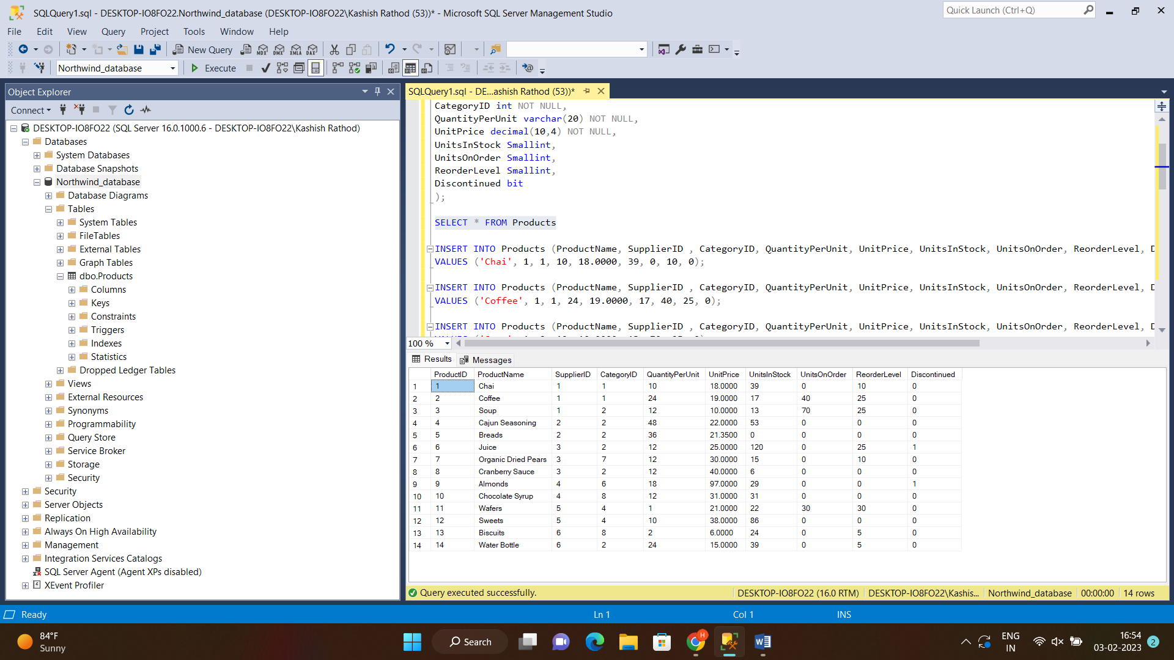

* Write a query to get a Product list (id, name, unit price) where current products cost less than $20.

SELECT ProductID, ProductName, UnitPrice

FROM Products

WHERE UnitPrice<20.0000;

Output:

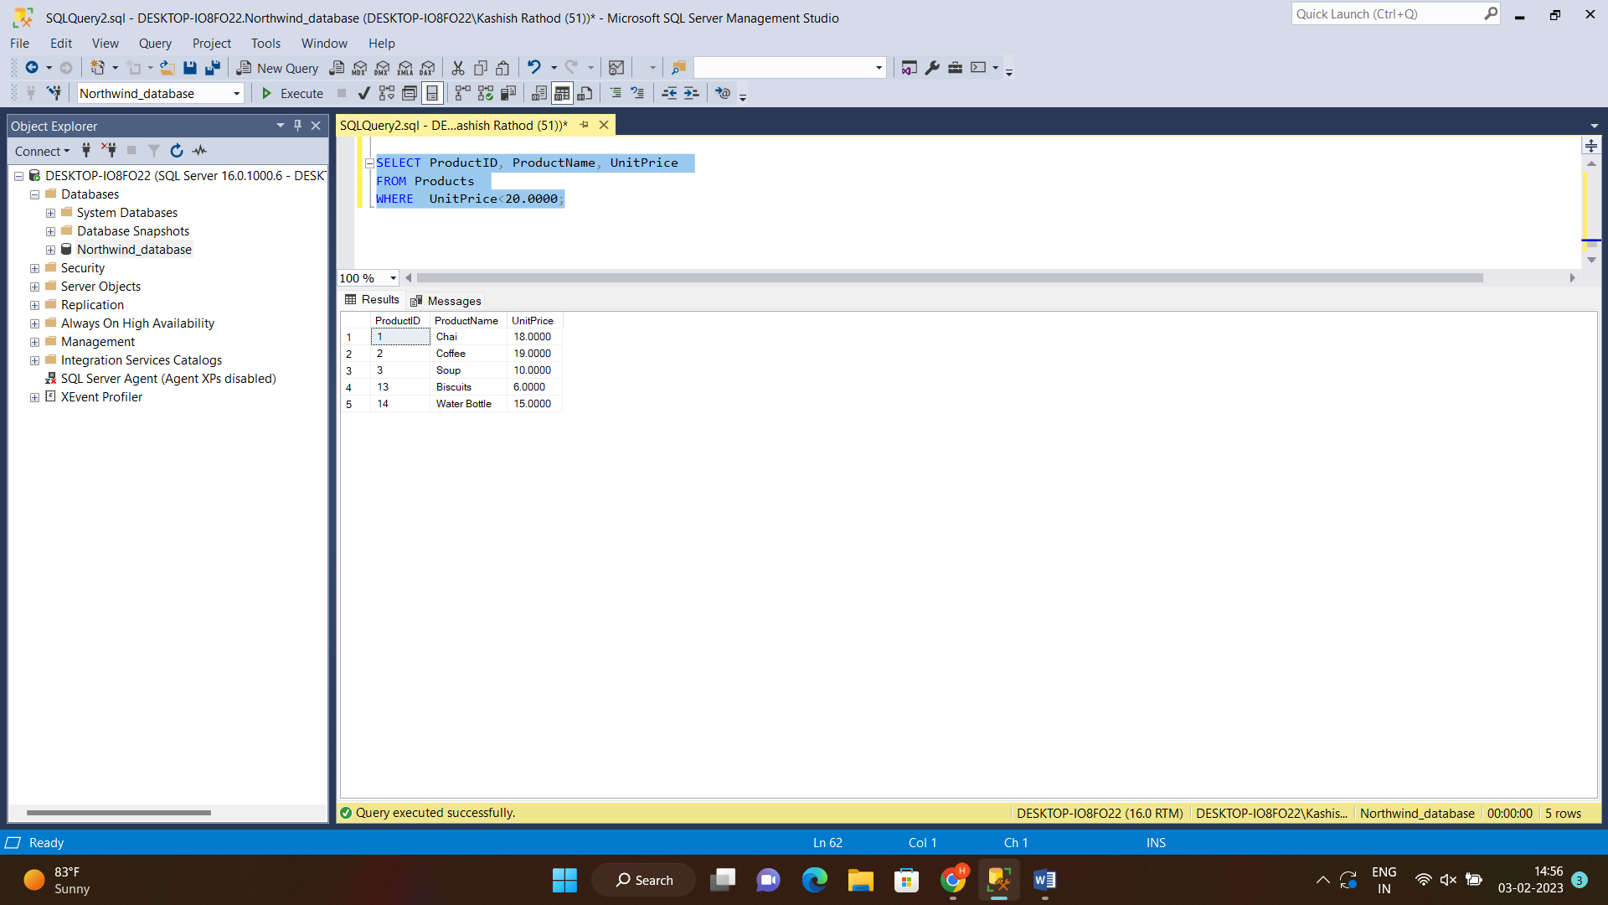

* Write a query to get Product list (id, name, unit price) where products

cost between $15 and $25.

SELECT ProductID, ProductName, UnitPrice

FROM Products

WHERE UnitPrice BETWEEN 15.0000 AND 25.0000;

Output:

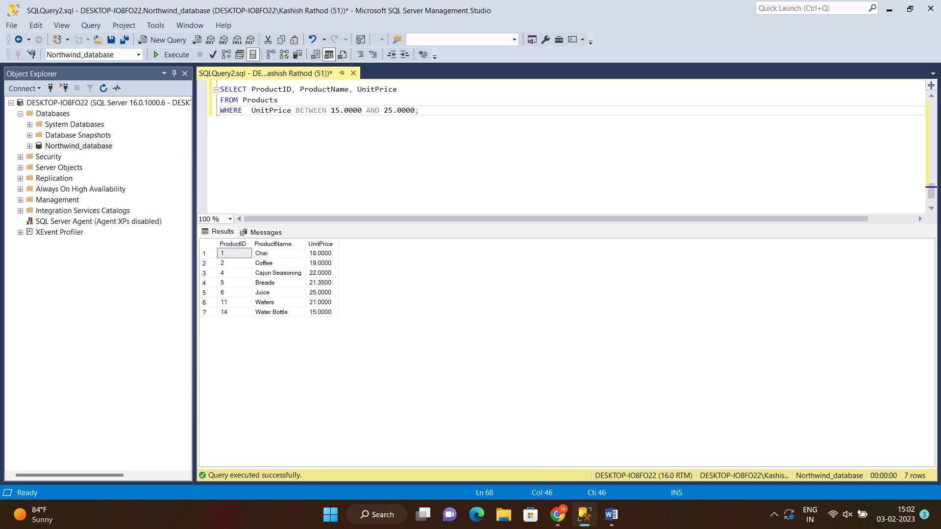

* Write a query to get Product list (name, unit price) of above average price.

SELECT AVG(UnitPrice)

FROM Products

(with AVG() function we find the average of unit price. And then we get our output with below query)

SELECT ProductName, UnitPrice

FROM Products

WHERE UnitPrice > 28.096428;

Output:

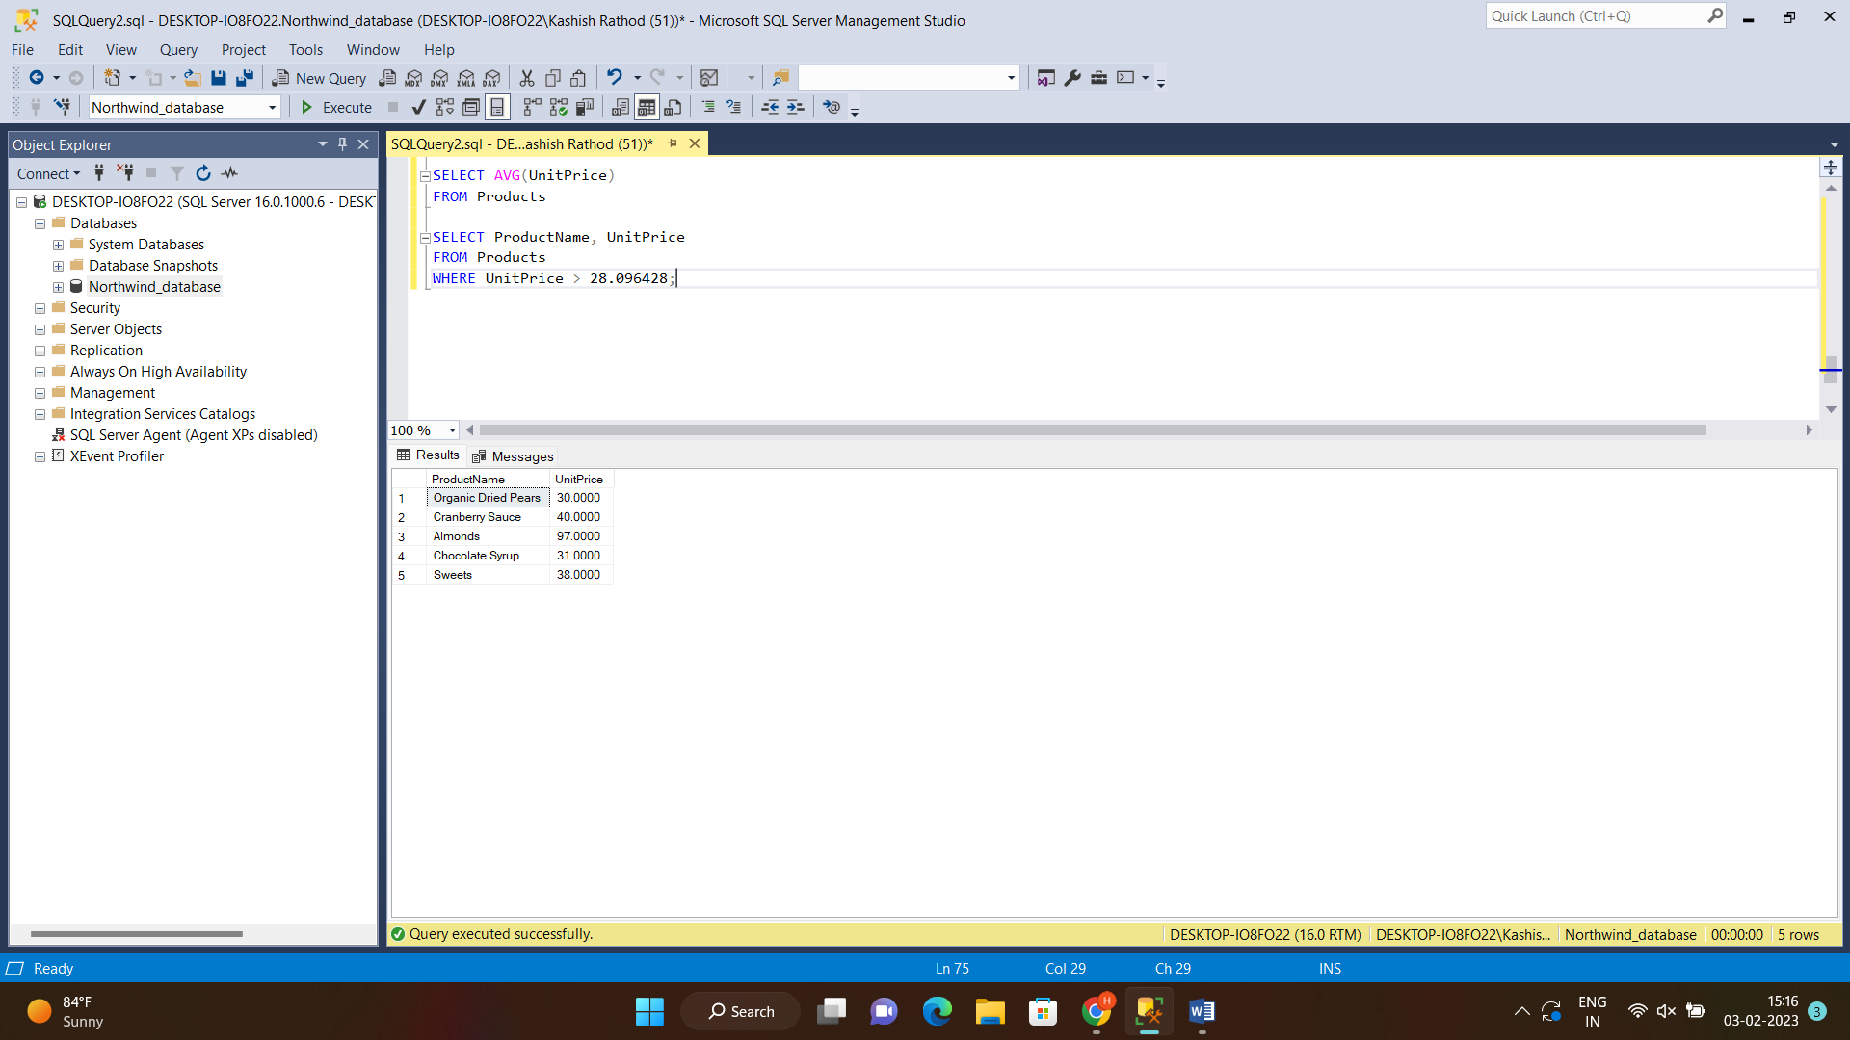

* Write a query to get Product list (name, unit price) of ten most expensive products

SELECT TOP(10) ProductName, UnitPrice

FROM Products

ORDER BY UnitPrice DESC;

Output:

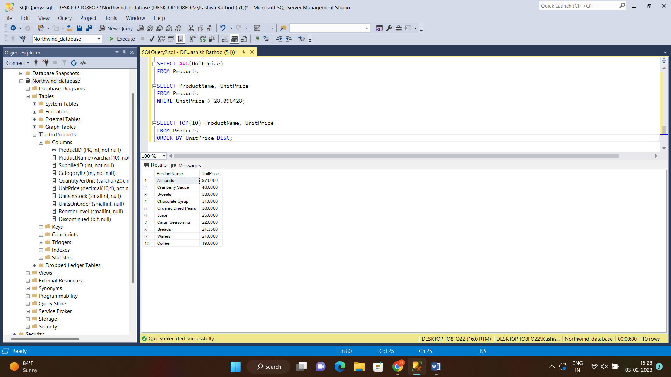

* Write a query to count current and discontinued products

SELECT COUNT(Discontinued)

FROM Products

WHERE Discontinued = 1;

Output:

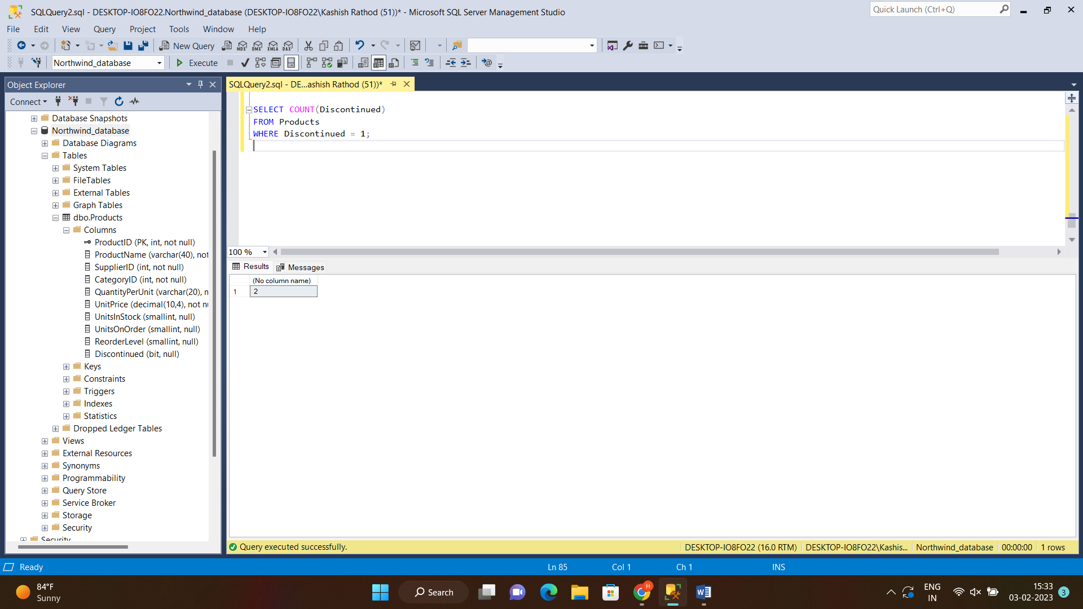

(For Current)

SELECT COUNT(Discontinued)

FROM Products

WHERE Discontinued = 0;

Output:

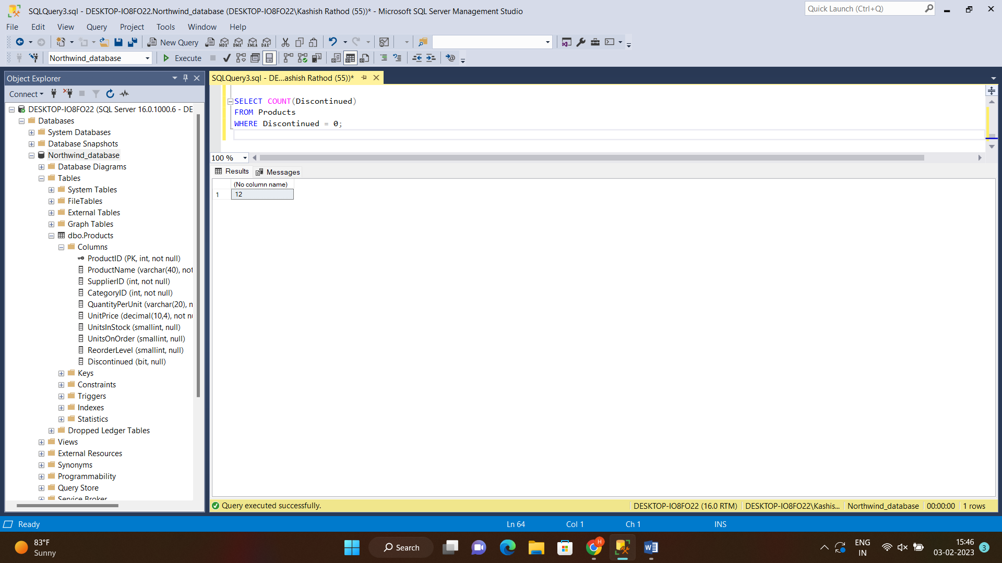

* Write a query to get Product list (name, units on order , units in stock) of stock is less than the quantity on order.

SELECT ProductName, UnitsOnOrder, UnitsInStock

FROM Products

WHERE UnitsInStock < QuantityPerUnit;

Output:

